A.1 Training
A.1.1: Distinguish between training, overtraining and overreaching.
Training is performing exercise in an organized manner on a regular basis with a specific goal in mind (cross reference with 6.2). Overtraining is when an athlete attempts to do more training than he or she is able to physically and/or mentally tolerate.
Overtraining results in a number of symptoms that are highly individualized.
Overreaching is transient over-training.
A.1.2: Describe various methods of training.
• strength and resistance training
Description: making use of the gym equipment and using external resistance to improve muscular strength and endurance.
- Benefits: Can isolate particular muscle groups to focus on. In a controlled setting, easy to manipulate the weight desired.
- Safety: Correct technique must be used or else it will create negative effects and increase the risk of injury.
• circuit training
Description: Short time spent at many different types of exercises. High intensity
- Benefits: can be general training or be made to suit specific components of fitness. Can be made to use no equipment, interesting as there is a wide ranger of activities - higher motivation.
- Safety: needs a large area for stations to be set up. If done in close confines it is more likely for an accident to occur.
• continuous training
Description: aerobic training for long periods of time. Could be an hour long jog or a extensive cycle.
- Benefits: Improves stamina which is important for many sport situation. No equipment needed and can be done anywhere.
- Safety: needs to make sure that it doesn't surpass what the body can handle
• cross-training
Description: using various methods of training in a single session
- Benefits: can train more than one type of fitness at once. Avoids tedium.
- Safety: need to make sure the proper technique is used in the equipment
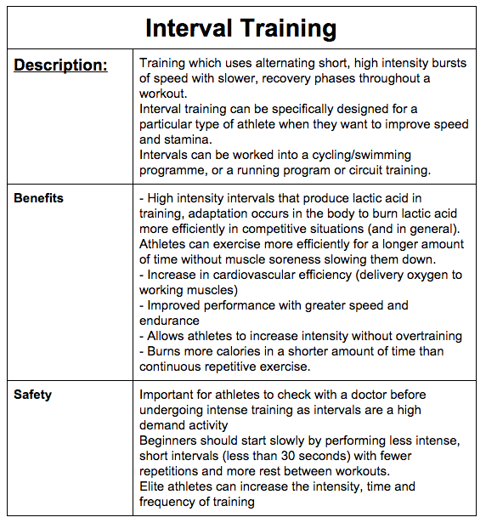
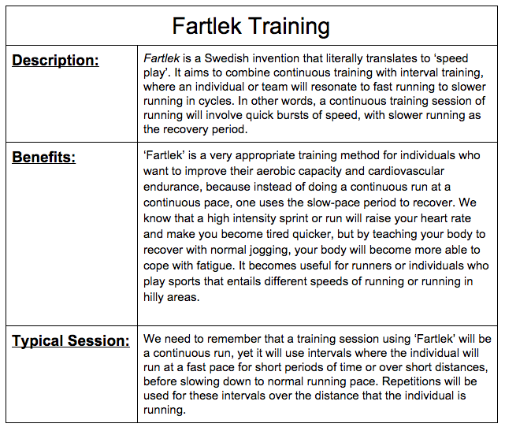
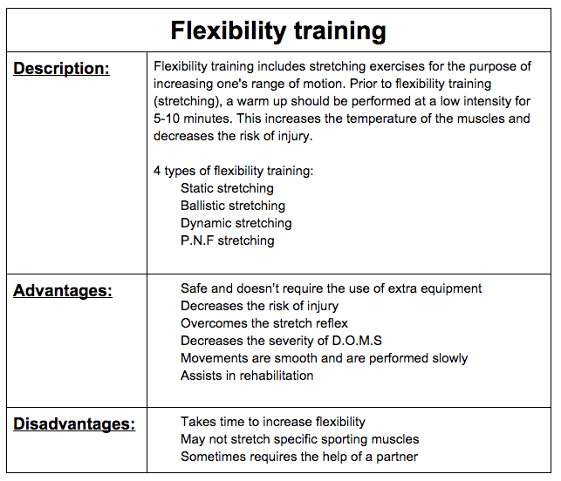
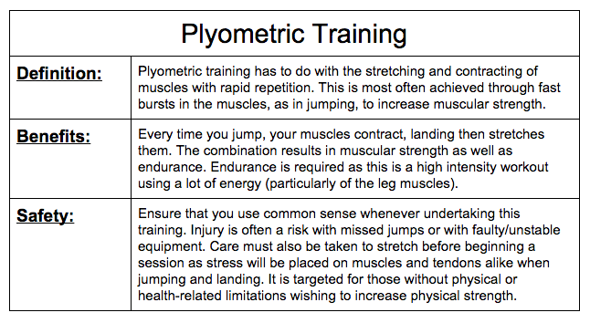
A.1.3: Discuss possible indicators of overtraining.
Overtraining: when an athlete attempts to do more training than they are physically or mentally capable of tolerating
- resting heart rate increases
- chronic muscle soreness is developed
- reduced immune function and frequent upper-respiratory tract infections (coughs and colds)
- sleep disturbance
- fatigue
- decreased appetite
- sudden and unexplained decrease in performance
- increased oxygen consumption
- increased lactate levels at fixed workload
A.1.4: Discuss how periodization should be organized to optimize performance and avoid overtraining and injury.
Periodization is the organization of training throughout a season so that an optimal physiological and psychological peak can be reached. In its simplest form periodization consists of 3 stages:
- Resting Phase or Transition (Post season)
- Pre-season (1) Preparation and (2) Pre competition
- Competitive Season
Microcycle | Mesocycle | Macrocycle
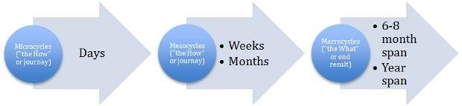
How one organizes training over a time frame of a year in order to reach peak at the desired time during the most important competition of their season.

A.2 Environmental factors and physical performance
A.2.1: Explain the relationship between cellular metabolism and the production of heat in the human body.
The production of heat in the human body
- All energy originates from the sun as light energy
- Chemical reaction in plants convert light into stored chemical energy
- We obtain energy by eating the plants or animals containing the energy
- The body utilizes oxygen and food to produce energy - the reaction dependent on the mixture of macro and micro nutrients in the presence of oxygen
- energy metabolism is controlled by many hormones including: insulin, glucagon, adrenaline and growth hormones
- Basal metabolic rate: amount of energy expended daily at rest, release of this energy is sufficient only for basic daily routine
Cellular metabolism (metabolic rate) are the chemical reactions taking place in human cells which are responsible for the maintenance of life
We get our energy from food, which is chemically released within our cells as energy. This energy is stored in bodily tissues as a more dense energy compound called adenosine triphosphate (ATP). The splitting of ATP is what provides to muscles with energy to contract.
Heat is a byproduct of metabolism: to get rid of the heat, it must be transferred away from the core, and be redistributed to the skin, where it can be lost to the environment.
- When metabolism increases, more heat is produced
- When metabolism decreases, less heat is produced
Humans require ENERGY to:
1. produce heat in order to maintain the internal body temperature at around 37°C
2. to produce force (mechanical work) during muscle contraction
Muscle contraction is about 20 percent efficient, with around 80% of this energy released as heat which must be removed from the body to avoid heat storage and too much of an increase in body temperature through:
(1) Conduction, (2) Convection, (3) Radiation & (4) Evaporation
ATP exists in every living tissues and its breakdown (aka catabolism) gives energy for all life functions eg. action of the liver, brain and contraction of muscle tissue
∙ Muscular-skeletal system through catabolic reactions convert biochemical energy from organic molecules into ‘mechanical’ energy (muscle contraction) and then ultimately to heat energy…a molecule called adenosine triphosphate (ATP);

A.2.2: State the normal physiological range for core body temperature.
37 degrees
0.6 + or - degree of error

A.2.3: Outline how the body thermoregulates in hot and cold environments.
Thermal receptors are present in the hypothalamus and in the skin. They have sensors for heat and cold.
Thermal effectors respond to the stimuli sensed in the receptors. They are the skeletal muscles, smooth muscles, and sweat glands.
In the COLD:
- muscles shiver
- skin blood supply is reduced (vasoconstriction)
- prolonged exposure to cold results in an increase in metabolic heat production due to the increased output of thyroxin from the thyroid gland and epinephrine from the adrenal medulla
In the HEAT:
- skin blood supply increased (vasodilation)
- sweating
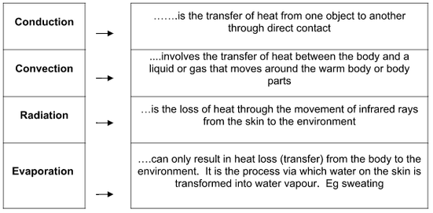

A.2.4: Discuss the significance of humidity and wind in relation to body heat loss.
Hot environments
The body uses the principles of conduction, convection, radiation and evaporation
Exercise in the heat or humid conditions reduces the thermal gradient between skin and environment and thus between the skin and core. Humidity imposes a heat loss barrier to the evaporative process and this severely limits our ability to perform. This then puts more pressure on the circulatory system and the result is an elevated heat rate.
When exercising it is important to remember that:
- If you were exercising (which produces heat) or enter a steamy sauna, your skin blood vessels would vasodilate to direct that warm blood towards the skin surface so heat can be dispersed.
- During heavy work, muscles need more blood flow, which reduces the amount of blood available to flow to the skin and release the heat.
In the wind:
Wind increases the speed of evaporation as it carries the sweat particles away. The wind increases the thermal gradient.

A.2.5: Describe the formation of sweat and the sweat response.
Sweating causes a decrease in the core temperature of the body (sweating cools the body). Heat stored in the blood is sent to the skin by vasoconstriction directing it so the heat can escape the body and evaporate away from the skin, down a concentration gradient.
Sweating is more common in hot environments as the body, in use of homeostasis, wishes to keep its temperature at the optimal temperature. Sweating is more persistent in humid climates as the rate of evaporation is less due to the density of water in the air surrounding the performer.
Sweating rate depends on the following:
∙ intensity of the activity
∙ environmental conditions
∙ fitness
∙ acclimatization
∙ type and amount of clothing worn

A.2.6: Discuss the physiological responses that occur during prolonged exercise in the heat.
Physiological Adaptations - Maximal sweat rates can reach 2-3 L per hour which means:
o Loss of fluid
o Loss of body mass
o Decrease in plasma volume
o Altered electrolyte balance
o Less urine production due to the retention of sodium and fluids
o Decreased central blood volume and stroke
o Decreased stroke volume
o Increased heart rate and thus more cardiac work

A.2.7: Discuss the health risks associated with exercising in the heat.
A.2.8: Outline what steps should be taken to prevent and to subsequently treat heat-related disorders.
Heat-related disorders include
- heat cramps
Symptoms: painful cramps (legs), flushed and moist skin
Treatment: move to a cool place and rest, remove excess clothing and place cool cloths on the skin, fan skin, drink sports drinks containing salt and sugar (gatorade), stretch cramped muscles slowly and gently.
- heat exhaustion
Symptoms: muscle cramps, pale moist skin, high fever, nausea, vomitting, diarrhea, headache, fatigue, weakness, anxiety and faint feeling
Treatment: move to a cool place and rest, remove excess clothing and place cool cloths on the skin, fan skin, drink sports drinks containing salt and sugar (gatorade), if no improvement or unable to take fluids, go to an emergency department immediately, IV (intravenous) fluids may be needed
- heat stroke.
Symptoms: warm and dry skin, high fever, increased heart rate, loss of appetite, vomitting, diarrhea, headache, fatigue, confusion, agitation, lethargy, stupor, seizure, coma, death
Treatment: move to a cool place and rest, call 911, medical emergency, remove excess clothing and drench skin in cool water, fan skin, place ice bags on armpits and groin areas, offer cool fluids is alert and able to drink
Because of their relatively large body surface area and immature sweat response, infants, children and young adolescents are more susceptible to complications associated with exercise performed in the heat and the cold.

NOT FINISHED** A.2.9: Describe how an athlete should acclimatize to heat stress
Performing training sessions in similar environmental conditions (heat and humidity) for 5 to 10 days results in almost total heat acclimatization. Initially, the intensity of training should be reduced to avoid heat-related problems in these conditions.
National representative teams/sportspeople choosing to acclimatize to the conditions of a host country during a major international sporting competition could be considered.

NOT FINISHED*** A.2.10: Discuss the physiological and metabolic adaptations that occur with heat acclimatization

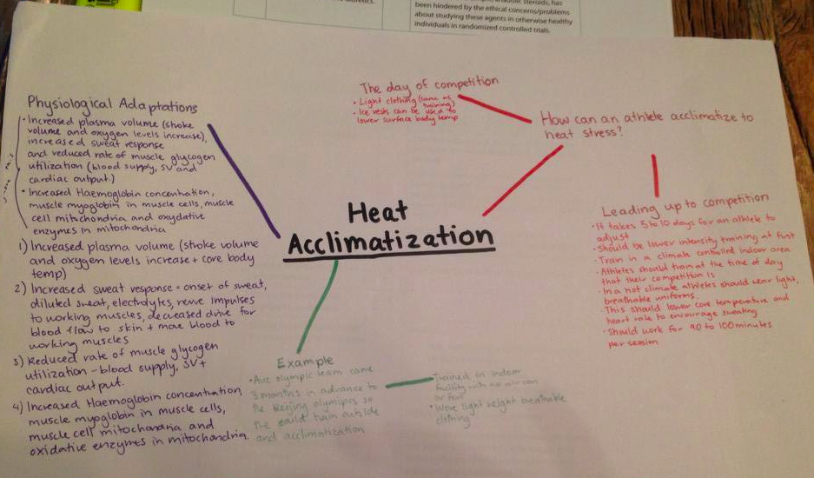

A.2.11: Outline the principal means by which the body maintains core temperature in cold environments
Shivering: uses energy to try to boost the heat production
Peripheral Vasoconstriction: restrict any heat being lost out of the body
Non shivering thermogenesis: increased heat production due to enhancement of normal calorigenic metabolic processes. thermogenesis resulting from the effects of the sympathetic nervous system neurotransmitters, epinephrine, and norepinephrine, acting to increase the cellular metabolic rate in skeletal muscle and other tissues, thereby increasing heat production. In a specialized form of adipose tissue, brown fat, the effect of the sympathetic neurotransmitters is to increase the rate of uncoupled oxidative phosphorylation by the mitochondria, which results in heat production without formation of adenosine 5'-triphosphate.
A.2.12: Explain why the body surface area-to-body mass ratio is important for heat preservation

A.2.13: Outline the importance of windchill in relation to body heat loss

A.2.14: Explain why swimming in cold water represents a particular challenge to the body’s ability to thermoregulate
- cold water is cold and icy and swimming in general is not fun. overall body not very happy (understandably)

A.2.15: Discuss the physiological responses to exercise in the cold
- Muscle function
- Metabolic rate

A.2.16: Describe the health risks of exercising in the cold, including cold water.
Frostbite and Hypothermia
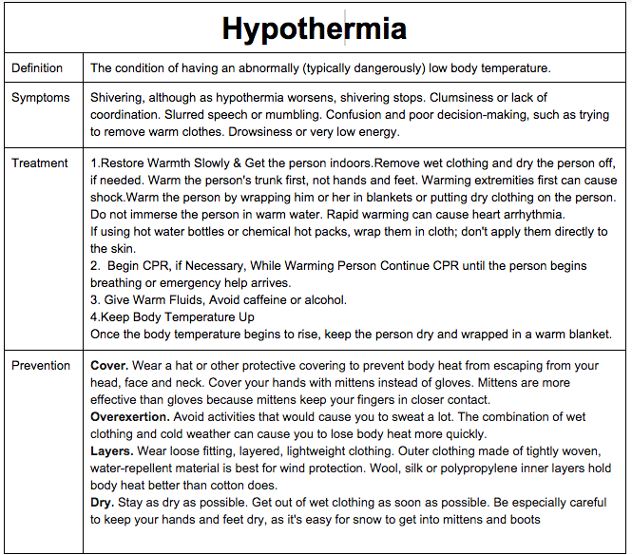

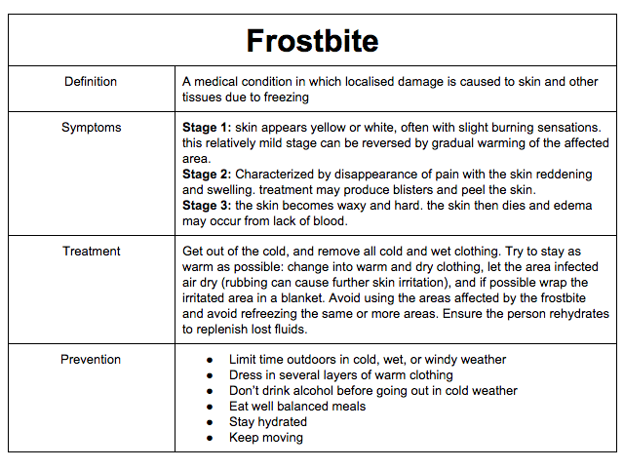

A.2.17 Discuss the precautions that should be taken when exercising in the cold
Clothing is important in retaining body heat and maintaining a higher core body temperature. Layering is often used to increase the effect of this as well as particular types of clothing. Clothing is important in controlling your body temperature and preventing health issues related with the cold.
Insulation is measure in CLO, a unit which makes up an index relating articles of clothing to the efficiency with which they insulate the body.’0’ CLO’s is the equivalent of a naked person, whereas ‘1’ is a completely insulated person
Dehydration is a problem in the cold weather as well, the combination of heavy clothes and intense exercise can result in fluid loss and hence is a danger in exercising in cold environments. Drinking plenty of fluids is an important way to combat the dangers of dehydration in the cold
Inhaling cold air According the a research journal, the effects of inhalation of cold air during exercise for 6 subjects are as follows; Heart rates and minute ventilations during the most strenous exercise averaged approximately 170 bpm and 70 l, respectively. Diastolic blood pressure was significantly lower, during cold air inhalation. Oxygen uptake and respiration rate were not affected by cold air breathing; and no subject complaints were attributable to cold air inhalation. Recent studies in the literature suggest that cold air is not fully warmed in the upper respiratory passages; however, the present study observed only slight changes in measured physiological responses to rest and exercise with cold air breathing. To warm the air before you breathe it, use a scarf or mask.
Avoid Overdressing: Running and other forms of strenuous outdoor exercise can make the athlete feel as if it 20-30 warmer. Overdressing can lead to more sweating than the appropriate amount and layers would generate, and that sweating can cause the body to become wet and cold. In general, if dressed with appropriately, one should feel slightly cold when starting to exercise.

A.3 Non-nutritional ergogenic aids
A.3.1: Define the term ergogenic aid
An ergogenic aid is any substance or phenomenon that improves an athlete’s performance.
A.3.2: Describe, with reference to an appropriate example, the placebo effect.
Positive Effect:
- belief that a beneficial treatment or intervention has been received (physiological, behavioral, emotional or cognitive)
- often used as a control during experiments investigating treatments, used to control validity
Negative Effect:
- athlete may think they are experiencing negative effects (physiological, behavioral, emotional or cognitive)
- a endurance performer may ingest a sports drink containing carbohydrates or artificial sweetener

A.3.3: List five classes of non-nutritional ergogenic aids that are currently banned by the International Olympic Committee (IOC) and World Anti-Doping Agency (WADA)
A.3.4: Discuss why pharmacological substances appear on the list of banned substances.
• anabolic steroids (gives unfair advantage or added strength to the performer, can be dangerous with elevated aggression)
• hormones and related substances (stimulates growth quicker that others, unfair advantage)
• diuretics and masking agents (masks other illegal ergogenic aids that may have been taken)
• beta blockers (decreases heart rate so performer can be more steady, commonly desired in shooting or precision sports)
• stimulants (elevates heart rate, to get performer going, desired in fighting type sports)
A.3.5: Discuss the proposed and actual benefits that some athletes would hope to gain by using anabolic steroids, erythropoietin (EPO), beta blockers, caffeine and diuretics.
A.3.6: Outline the possible harmful effects of long-term use of anabolic steroids, EPO, beta blockers, caffeine and diuretics.
Anabolic Steroids:
Artificially produced hormones.
Benefits:
- promote muscle growth
- produces lean body weight
Side Effects:
- liver damage
- acne
- excessive aggression
Erythropoietin (EPO):
A natural hormone produced by the kidney that promotes the formation of red blood cells in the bone marrow, which increases haemoglobin levels.
Benefits:
- increases oxygen-carrying capacity
- increase amount of work able to be done (muscular endurance)
Side Effects:
- dehydration
- viscosity of the blood
- blood clotting
- risk of heart attacks, strokes causing death
Beta Blockers:
Help to calm an individual down (lowers the heart rate).
Benefits:
- steadies the nerves
- can improve accuracy
Side Effects:
- tiredness
- low blood pressure
- slower heart rate

Caffeine (Stimulants):
Increase alertness and physical processes in the body.
Benefits:
- improve the mobilization of fatty acids
- decreased tiredness
- increases metabolism
- increased alertness
Side Effects:
- dehydration
- insomnia
- weight loss
- cardiovascular problems causing death
Diuretics:
Drug that can conceal the presence of a prohibited substance in urine or other samples.
Benefits:
- mask other performance enhancing drugs
Side Effects:
- dehydration
- upset stomach
- feeling faint
- dizziness and low blood pressure
- affects thermoregulation
- loss of electrolytes and mineral salts --> fatigue and muscle cramping
- exhaustion and cardiac arrest
- kidney failure

